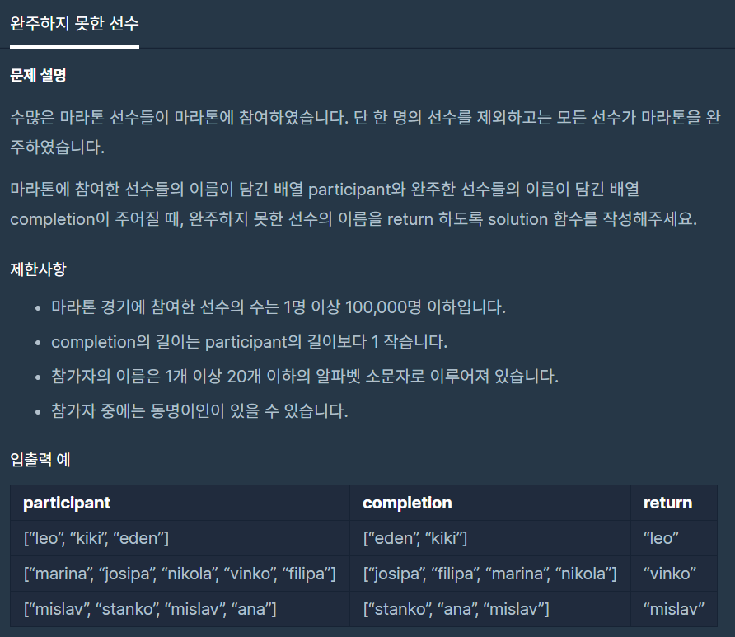

**문제 링크주소 :** <https://programmers.co.kr/learn/courses/30/lessons/42576>

**풀이**

function solution(*participant*, *completion*) {

*participant*.sort();

*completion*.sort();

    for(var i=0; i<*participant*.length; i++){

        if(*participant*[i]!==*completion*[i]){

                return *participant*[i];

        }

    }

}